Experiment 1

AIM: Write a program which defines a class User with attributes id, password, first name, last name, gender, total marks, and result. It should have 2 methods, namely, printDetails() and login(), on successful login print the details.

Theory:

A Class is a user defined data-type which has data members and member functions. Data members are the data variables and member functions are the functions used to manipulate these variables and together these data members and member functions defines the properties and behavior of the objects in a Class. An Object is an instance of a Class. The public data members are also
accessed in the same way given however the private data members are not allowed to be accessed directly by the object. Accessing a data member depends solely on the access control of that data member.This access control is given by Access modifiers in C++. There are three access modifiers : public, private and protected.

Code:

- #include < iostream >

- #include < string >
- using namespace std;

- class User {
- string id, password, firstName, lastName;

- char gender;
- int totalMarks;

- bool result;
- void printDetails() {
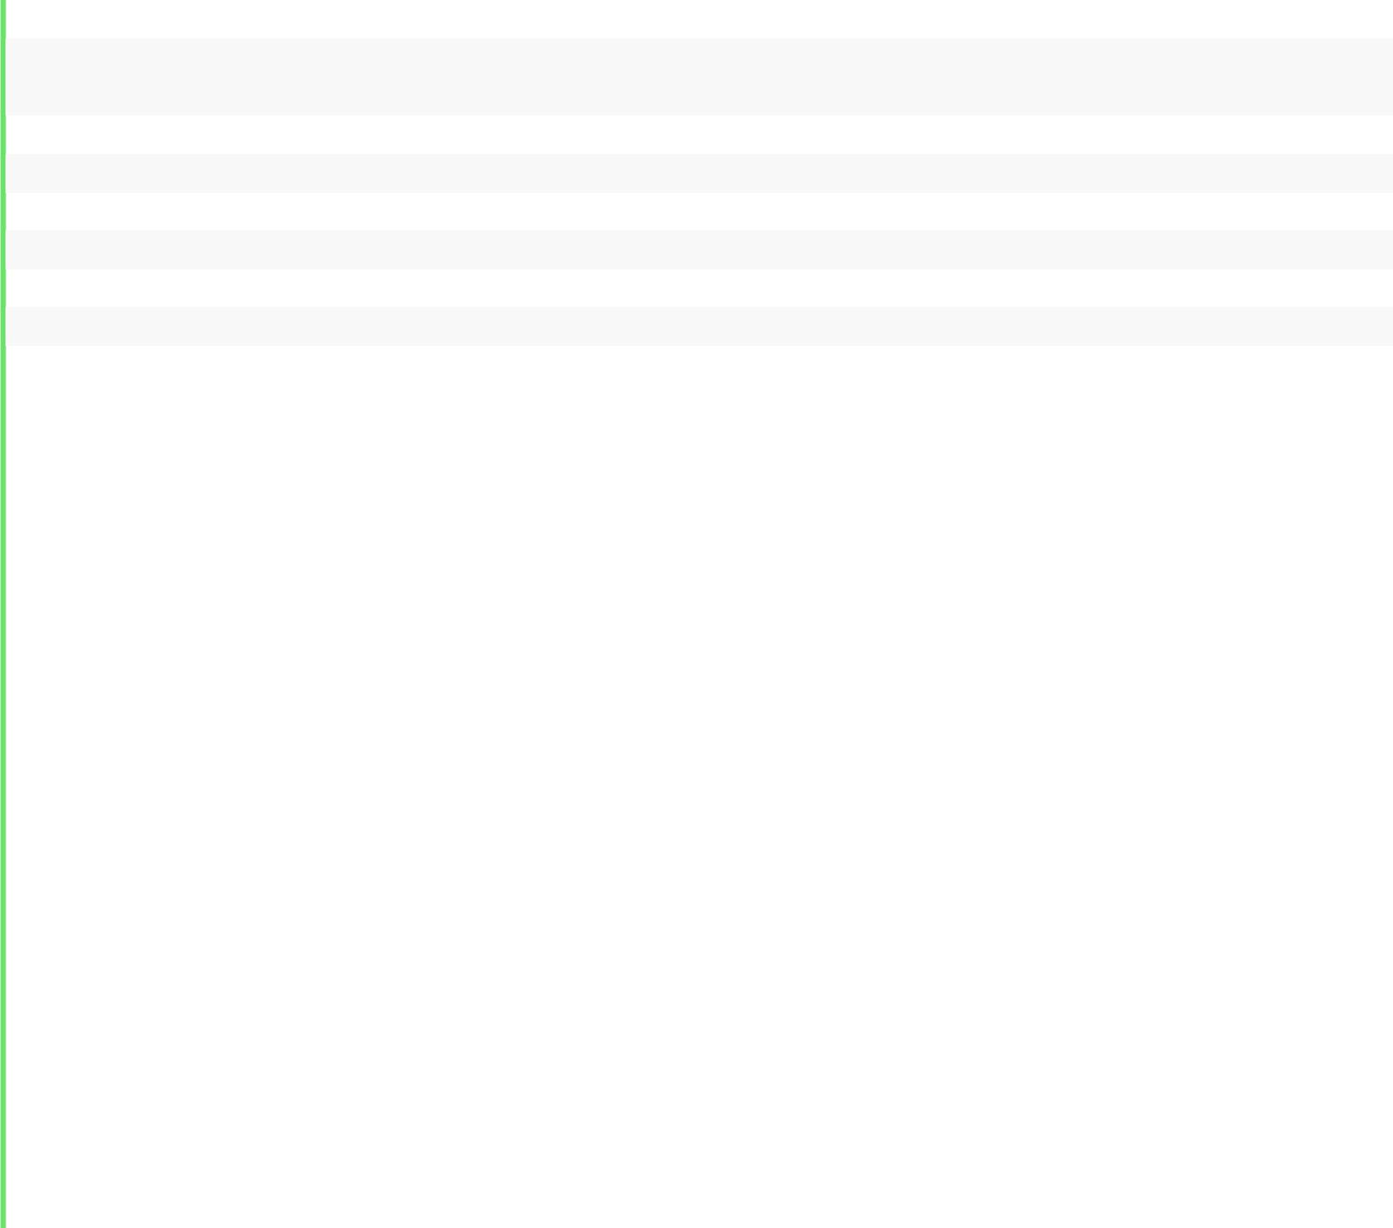
10. cout << "Name: " << firstName << " " << lastName << endl;
11. cout << "Gender: " << gender << endl;

12. cout << "Total marks: " << totalMarks << endl;
13. cout << "Result: " << (result ? "Pass\n" : "Fail\n");
- }

- public: User(string i, string pass, string fn, string ln, char g
  - int tm) {
16. | id = i;
17. | password = | pass;
18. | firstName = fn;
19. | lastName = | ln;
20. | gender = g;
21. | totalMarks | = tm;
22. | result = (tm >= 50) ? 1 : 0;
- }
- void login() {

25. | string i, | p;
26. | cout << "Enter id: ";
27. | cin >> i;
28. | cout << "Password: ";
29. | cin >> p;
30. | if (i == id && p == password) printDetails();
31. | else cout | << "Unauthorized!\n";

- }

- };

- int main() {
- User dj("dhananjay", "123456", "Dhananjay", "Negi", 'M', 100);

- aneesh.login();
- return 0;

- }
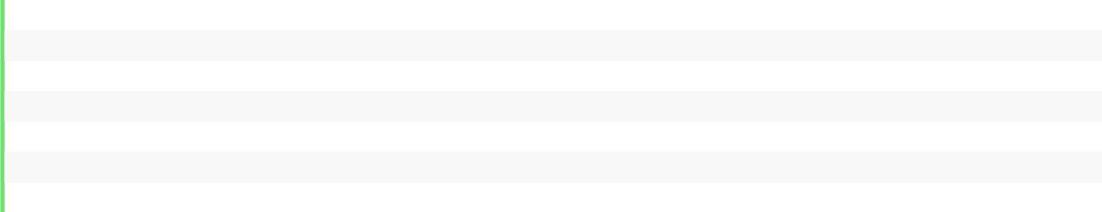

Output:
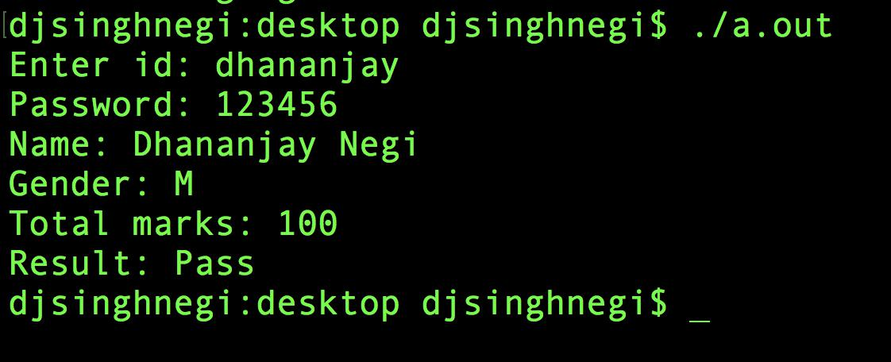

Discussion:

The class User stores details like, id, password, name, gender, total marks, and result. The instance aneesh is created with the relevant details. The method login() is called on this instance which authenticates the user and on success shows the details. On failure it displays, “Unauthorized!”.

